Table of Contents

Project Overview…………………………………………………….3
Introduction…………………………………………………………..4
Project Goals…………………………………………………………8
Methodology…………………………………………………………9
Resources……………………………………………………………15
Our Team…………………………………………………………….16
Bibliography…………………………………………………………17

Project Overview

Decibility was created by Kristen O’Neill, Riham Majeed, Deborah Marcelus, and Judyath Thomas (all of whom are seniors at Central Magnet High School and BRASTEC) to address an issue close to them.
The objective of Decibility: A World With No Sound is to create a product that will monitor the levels of music, as this will prevent noise induced hearing loss (NIHL). It is also to bring awareness to the prevalent issue of how extremely loud music can be damaging to this organ and cause hearing loss. So many of our peers are prone to listening to music very loudly, but remain completely unaware of the dangers this habit brings. Our main focus is on headphone usage, because of its vast popularity and also because it exposes the ear to extremely close range of loud decibels. Decibels are a tenth of bel, a unit that measures the intensity of sound. Extremely high decibels can cause denaturation in the proteins of the hair cells (stereocilia), located in the inner ear. One of these proteins, Cadherin-23 is a part of the tip-links of the stereocilia. It functions to hold the hair cells together and act as a cohesive unit. This protein will denature when loud noises are exposed to it. However, Cadherin-23 can regenerate, but it is uncertain of how the protein regenerates or for how long. In addition, loud sounds can also rupture the bonds between two proteins, Cadherin 23 and Protocadherin-15.
The S.I.M.P.L.E (Sound Intensity Meter for Personal Listening Enjoyment) Campaign is our awareness campaign to help educate our peers and adults in order to prevent NIHL. The main problem we faced was the relativity of measuring sound using just our ears. How loud was too loud, and how would that translate from one person to another? Our solution is SiM (Sound Intensity Meter). This product will measure electrical signals through a microprocessor chip and will convert the signals into decibels. This information will then be translated onto a liquid crystal display screen (LCD). A design case can be implemented to attach SiM to any type of iPod or IPhone. The display would not only show the average intensity of music, but also the time spent listening to the music. The bio-mimicry involved is the transcribing/translating of the sound waves into electricity. Many processes in nature use transcription/translation, such as when we convert food into energy or DNA to proteins.

Introduction

The human ear is a very sensitive and complex organ. Exposure to loud noises can cause serious damage within the ear and result in NIHL. A large scale American national health survey indicated that anywhere from 12 to 15% of school aged children had hearing problems attributed to noise exposure. An Australian study concluded that while there was “no widespread hearing loss caused by recreational noise”, teenagers would be at high risk for NIHL by their mid-20s, “if recreational habits remained the same.” Loud noises like sirens, construction work, and city traffic may be inevitable exposures, but high music levels are not.
Stereocilia are a part of the hair cells located in the inner ear canal on the Organ of Corti. Stereocilia are made up of cytoplasm and actin filaments. The Organ of Corti contains 4 rows of inner and outer hair cells. The first three rows are made up of outer hair cells while the last row is made up of inner hair cells. The outer hair cells mainly focus on amplifying sound signals and mechano-transduction, which is the conversion of mechanical energy into electrical energy. The inner hair cells also take part in transducing sound, however their main function is to process the auditory information.
When sound vibrations enter the ear, they go to the cochlea, a spiral-shaped tube that holds the Organ of Corti. The stereocilia begin to move or respond to the sound vibrations emerging and create electrical impulses. These electrical impulses are then sent to the cerebral cortex in the brain and are processed. This is how the brain recognizes sound. There are about 16,000-20,000 stereocilia in an average person. If loud noises enter the ear, the proteins located on the tip links of the hair cells begin to denature. Cadherin 23 and Protocadherin 15 are two of the proteins that make up the tip-links.
Figure 1: This is an illustration of the protein Cadherin 23 within the tiplink connecting the cells together.
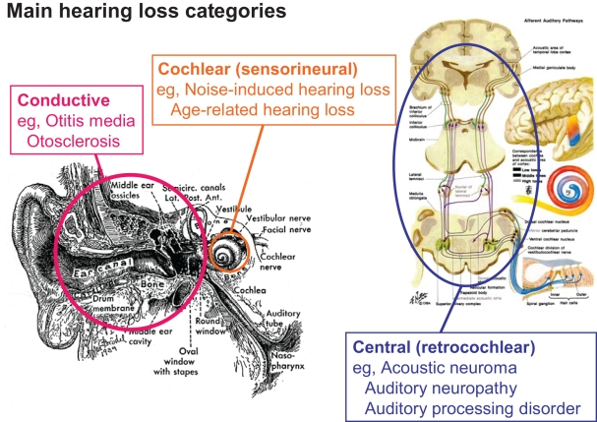
The proteins can regenerate but for only a period of time. If these proteins denature, the rigid structure of the stereocilia will weaken, therefore weakening the electrical signals going to the brain. Sensorineural hearing loss occurs when the cochlear structure or hair cells in the structure are damaged. This can be caused by excessive noise exposure. Sensorineural hearing loss is the most common type of hearing loss and people with this type of hearing loss complain of muffled sounds. There is no cure however, many people wear hearing aids and cochlear implants.
Figure 2: Main Hearing Loss Categories
Noise Induced Hearing Loss, or NIHL, is caused by exposure to noise over 85 decibels for various amounts of time. It is classified as cochlear, or sensorinueral hearing loss, mainly affecting the cochlea of the inner ear. It affects 2% of the world’s adult population - that’s about 80 million people over the age of 24. As of 2010, about 10 million adults and 5.2 million children in the US were suffering from irreversible NIHL. Thirty million more were exposed to dangerous levels of noise every day. While previously common only in adults through occupational exposure, the advent of personal listening devices, and a public slowly becoming more aware of the risks, has shown that children are at risk for developing NIHL and tinnitus. In an Oregon study of 1,120 fourth grade students, it was found that 94.5% of them were at risk for NIHL.
But studies have not only been conducted in America;
- A Scandinavian study on over five hundred teenage boys found a hearing loss greater than 15 dB in 15% of them.
- A German review of clinical data concluded that one in ten adolescents may have some degree of NIHL due to “leisure time noise.”
- A Chinese study found that of the subjects using “personal listening devices”, 14% of them had a hearing loss of more than 25 dB.
- A French survey found hearing problems in 12% of the general sample and that 66% of the subset that attended rock concerts or used “personal listening devices” more than 7 hours a week had hearing loss.
- A German study of a smaller group had similar results.
- A Swedish study of 55 boys (eight to 20 years old) seeking help for tinnitus, found that the majority had been exposed to excessive noise, mostly from recreational music
This shows a universal, growing issue. Even an Australian study, which concluded that while there was “no widespread hearing loss caused by recreational noise”, teenagers will be at high risk for NIHL by their mid-20s “if recreational habits remain the same.” Because tinnitus is often coupled with the hearing loss, the effect can greatly reduce someone’s quality of life.
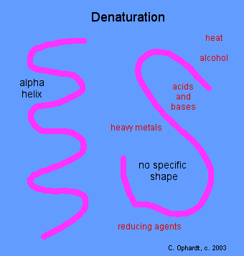
Tinnitus is generally classified as a ringing in the ears, though can be anything from buzzing to a sound like ocean waves, according to the American Tinnitus Association. While there are many causes for tinnitus development, a study done in Berlin of 581 patients with chronic tinnitus found that 83% also had noise induced hearing loss. Tinnitus can be temporary, persistent, or even shifting – where the sound may take breaks for short periods of time. In general the sound is distressing and irritating – it can make people anxious. A brain imaging study conducted in the 1990’s supports this by showing in some cases, tinnitus affected patient’s limbic system – the emotional center of the brain.
Proteins are one of the four organic compounds that are fundamental to human life. They are made up of the amine group, the R group and the carboxyl group. The primary protein structure refers to the exact sequence of amino acids in the protein. The amino acids are chained with multiple peptide bonds - which explains why they are called polypeptide chains (poly= many). Proteins have three layers of structure - primary, secondary, and tertiary. These layers fold together into the protein's main shape. The folds are held together by hydrogen and ionic bonding of the side chains of the amino acids and form alpha helixes grouped into beta sheets.
Figure 3: This is an illustration of how denaturation disrupts the structure of the alpha helix and the beta sheets in a protein. It uncoils into a random shape.
Denaturing is the breaking down of the secondary and tertiary structures in a protein - the primary structure stays intact. It causes the protein to unfold, which can prevent the protein from functioning normally, and sometimes prevents it from functioning at all. Proteins denature when they are heated, when their pH is changed (both acidic and basic), heat, and when they are exposed to high decibels.

Project Goals

The risk of NIHL is a global risk. Studies on adolescents have been conducted in many countries including the United States, France, Sweden, Australia, Canada, China, Germany, and Scandinavia. While the risk for children is greater, both due to their preference for louder music and the longer exposure time, an appreciation for music (what researchers call “leisure time noise”) spans across all races, ages, religions, cultures, and genders. While the type of music may vary, people in every conceivable subgroup are likely to abuse the volume controls at one point or another. Researchers’ advice is to set your personal devices to a comfortable level in a silent environment and try not to change it when exposed to a louder environment – such as a train or bus ride. Even free sound meter apps can’t help – because they measure decibels based on the sound waves, which are inaccurate in headphones.
The objective of the Decibility project is to design a product that will not only bring awareness to how loud noises can damage ears gradually, but also to allow people to monitor their volume in a simple way, in any environment. The product, SiM (sound intensity meter), will convert or analyze electrical currents from the headphone jack of a musical device to decibels. Decibels - a tenth of a bel named after Alexander Graham Bell, are units specifically for measuring sound intensity. When the energy is converted into decibels, the product will show the duration and the intensity of the music. This pertains to bio-mimicry because all organisms convert one form of energy into another. When a primate eats an apple, those nutrients in the apple become a form of energy for them. In a similar way, this product will convert the unit of electrical energy (amperes) running through the headphone wires into a sound energy unit (decibels). The product will be attached onto music devices like iPhones, iPods, and mp3 players, much like how cases and headphones are attached. The target audiences are those who listen to extremely loud music and people who listen for an extended period of time.

Methodology

SiM is the product that will measure the intensity of the music that people are listening to. It will convert the electrical current flowing in the wires of the headphone jack to decibels. There are three main components of SiM: ammeter, microprocessor chip, and display screen.
Ammeter
Ammeters (also known as amp meters) measure a wire’s magnetic field, thus determining how much current is flowing through the wire. The current, amount of electrical charge passing through a circuit in a specific amount of time, is measured in amperes.

Figure 4: A diagram of the components in clamp-on ammeters

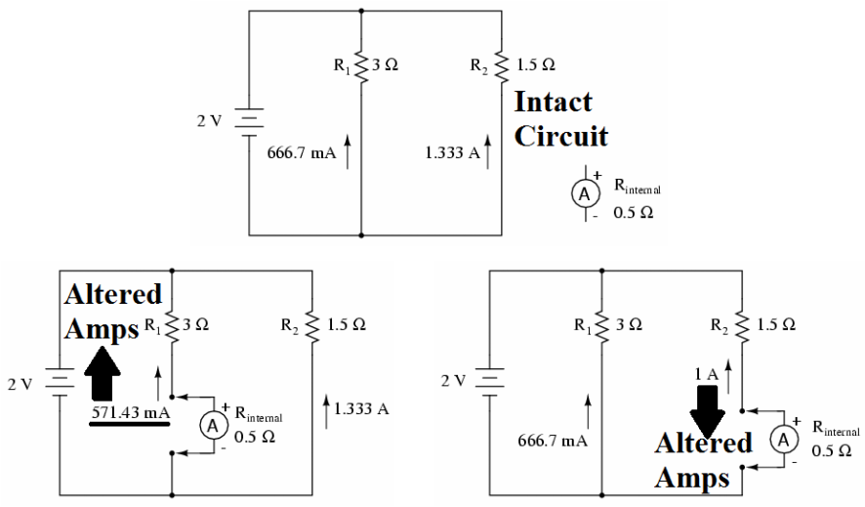

Traditional ammeters tap directly into the wire, which can actually give a false reading as the ammeter’s resistance (in ohms) changes the device’s resistance, and thus the current.
Clamp on meters, however, do not break into the wire. They measure the magnetic field of the wire, and do not add any resistance to the circuit, making it a very accurate way of measuring amps.

Figure 5: An illustration of how the clamp measures the current.

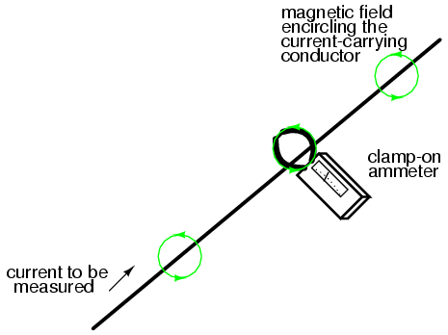

Figure 6: The illustration specific to the SiM Ammeter

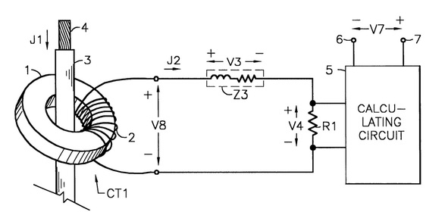

SiM uses a digital current transformer clamp-on ammeter. You can see why we just went with SiM. Anyway, the ammeter has a set of jaws that are made with a ferrous carbon metal – like ferrite. Around these jaws is a metal coil with a current running through it. When the current flows through the wire, it produces a magnetic field. When the magnetic field hits the jaws, it breaks the ammeter’s magnetic field. When the ammeter’s field breaks, magnetic signals are sent through the coils, which become electrical signals – a current equal to that of the wire being measured. As the current passes through the wires and transistors, it comes to a reading point before it enters the calculating circuit. In the calculating circuit is where the current is changed into data for the display screen, with the help of a transducer. In SiM, however, there is one more step before the data is displayed.

Microprocessor Chip
This main component will calculate or analyze the amount of electrical energy (amperes) to the sound unit (decibels). The information will be directed through a control unit. This control unit will take the already added information from the main memory and will be decoded into commands. Then it will send off the commands to the arithmetic logic unit (ALU). This unit is a digital circuit that can perform various integer operations. The unit will execute these commands and then store back into main memory.
This equation will be entered into the microprocessor chip to convert from amperes to decibels.
(A)= amperes, dbA= decibels in reference to amperes (20) = standard reference level log= logarithm
Equation: A to dBA dBA= 20log(A)

Figure 7: This is a visual representation of how the process inside a microprocessor will initiate. These units are used in many computers and calculators.

Control Unit

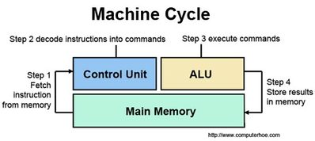

Figure 8: This is a diagram showing the process inside the simplest microprocessor.

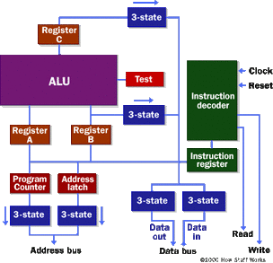

The microprocessor is used for moving data from one place to another and making a new set of instructions and then carrying them out. The simplest microprocessor contains an address bus, data bus, RD, WR, clock line, and reset line. The address bus sends an address to memory. The data bus can send or receive data from memory. An RD (read) and WR (write) are lines that tell the memory where to send or get the addressed location. The clock line is a timer or clock sequence for the processor. The reset line can restart execution. The registers A, B, and C are just latches as is the address latch. Latches are simply inputs that can set or reset the output for a combination. The program latch can increment more than one and can reset at zero. The ALU unit performs mathematical information. The test register is a latch that can compare two values. The six boxes are known as tri-state buffers. These buffers allow multiple outputs to connect to a wire. It can also easily disconnect its output. The information decoder and information register decodes and holds the information.
Liquid Crystal Display (LCD) Screen

This display uses light properties from liquid crystals. These display screens can emit words and numbers. This product is used on computers, television monitors, calculators, watches, alarm clocks, and portable electronic devices such as the iPhone. LCD's are energy efficient because of its low power consumption. It is also very light. The screen uses two sheets of polarizing material containing a liquid crystal solution between the two. An electric current passes through the liquid, which causes the crystals to form or align together so that light cannot pass through. The crystals act as a shutter and opens or closes, allowing the pixels of light to be passed or blocked. The crystals are colorized and the image becomes visible. This specific LCD screen will show the average intensity of the decibels and the duration of the music. Not only will it show the time and intensity, but it will also be programmed to show if the time and intensity is in the danger zone for risk of NIHL. A thin-film transistor also known as an active-matrix display will be used for its sharp image quality. In these color displays, each pixel contains a transistor. This allows the electric current radiating to be switched on and off at a faster rate, making the display brighter and imaging smoother. This way, any number of colors can be visible to the eye.

Figure 9: An illustration on the basis of how LCDs work.

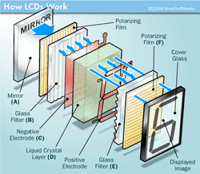

There is a mirror in the back; this allows it to be reflective. Then there is a piece of glass with a polarizing film on the bottom. After that, there is a common electrode plane made of indium-oxide on the top. Next, there is a liquid crystal substance and after that, there is another electrode. Finally there is a polarizing film along with a glass filter at a right angle to the first polarizing film. When there is no electrical current, the light will simply bounce back from the mirror. But if there is an electrical current, the liquid crystals from the common-plane electrode and the rectangle-shaped electrode untwist and block the light passing through it, This happens due to the angles not matching up, creating a dark portion in the display area.

Resources

Our advisory board comprises of scientists and connoisseurs that will provide extended knowledge or research on our tasks. One member, Marcos Sotomayor, is a postdoctoral fellow at the Harvard Medical School working in the Department of Neurology. A specialist in ear proteins, he created molecular dynamics displaying the denaturing of Cadherin 23, caused by the exposure of mechanical sounds. He also created videos that show the rupturing of the bonds between Protocadherin 15 and Cadherin 23, also due to loud noise exposures. He is one of the few scientists studying this currently, and is integral in our progress.
Dionna Williams, a graduate student working for her P.H.D, is currently working on the HIV virus and how it affects the neurons within the brain by passing through the Blood Brain Barrier (BBB). She is part of the advisory board because of her broad range of the proteins that can be helpful to use when there are experiments to be done.
Of course our teacher, Mrs. Ebmeyer, has to be included! Carla Ebmeyer is currently a Medical/Veterinary Lab and Biotechnology teacher at Bridgeport Regional Aquaculture Science and Technology Education Center. She attended Southern Connecticut State University and worked as a Medical Lab Technician before getting a Master’s Degree and teaching degree. She has been teaching at BRASTEC for 15 years, in subjects such as Medical/Veterinary Lab, Biotechnology and Biology. Besides being our Biotech teacher, she gives us advice and critiques on our materials for the exposition.

Our Team

Judyath Thomas: Communications Tycoon, Ear/Protein genius, Film Producer, and Most Valuable Player. She’s our lead researcher on the structure of the ear and the specific proteins in the hair cells. She, along with Riham communicated with the advisory board through media. She designed elements for the Facebook page and also keeps Facebook, Twitter, and the Decibility blog up-to-date. She created the documentary for the S.I.M.P.L.E campaign and advises Kristen on any ideas or information for the project. She discovered information on two components for SiM: the microchip, and display screen.
Riham Majeed: Researcher Executive, Tech Scientist, and Quality Assurance Lead. Riham is the jack-of-all-trades. Riham will perform and accomplish any task given to her. She discovered extensive research on the JOLENE technology systems and has creative product ideas. She has broad knowledge on the background information that was needed for the project such as relevant scientific experiments with proteins. She assisted in communication with advisors and keeps the Decibility blog up-to-date.
Kristen O’Neill: Leader, Webmaster, Head Designer, and NIHL expert. Kristen handles the uploading, design of the website, and construction of posters. She’s the creative energy behind the presentations and documents. She mainly works on the S.I.M.P.L.E. Campaign and gives direction/advice to the rest of the group. She also keeps the Facebook, Decibility Blog, and Twitter page up-to-date. More importantly, she researched and found vital information on one of our components for SiM: the ammeter.
Deborah Marcelus: Public Relations Boss and Protein Specialist. Deborah created the Facebook and Twitter Page for the S.I.M.P.L.E campaign. She also posts blogs on the website, Facebook, and Twitter. She discovered an article containing the information on the ear protein, Cadherin 23.

Bibliography

NIHL Resources
http://www.cdc.gov/healthyyouth/noise/
http://www.ncbi.nlm.nih.gov/pubmed/11433052
http://www.ncbi.nlm.nih.gov/pubmed/7280546
http://www.ncbi.nlm.nih.gov/pubmed/10407726
http://www.ncbi.nlm.nih.gov/pubmed/17711774
http://www.ncbi.nlm.nih.gov/pubmed/8864255
http://www.ncbi.nlm.nih.gov/pubmed/10615655
http://www.ncbi.nlm.nih.gov/pubmed/17485978
http://www.ncbi.nlm.nih.gov/pubmed/15604913
http://www.ncbi.nlm.nih.gov/pubmed/16717016
http://www.ncbi.nlm.nih.gov/pubmed/10615655
http://www.ncbi.nlm.nih.gov/pubmed/7121386
http://www.ncbi.nlm.nih.gov/pmc/articles/PMC2532893/figure/f1-pch13377/
http://www.ncbi.nlm.nih.gov/pubmed/17430434
http://www.ncbi.nlm.nih.gov/pubmed/23373742
http://www.ncbi.nlm.nih.gov/pubmed/21139857
http://www.ncbi.nlm.nih.gov/pubmed/20948948
http://www.indexmundi.com/world/demographics_profile.html
http://www.ata.org/sites/ata.org/files/pdf/What_is_Tinnitus_Tabachnick_%20Sept%20%2704.pdf
http://www.ata.org/for-patients/about-tinnitus#what%20is%20tinnitus
http://www.ncbi.nlm.nih.gov/pmc/articles/PMC2532893/
Stereocilia and Protein Information
http://www.elmhurst.edu/~chm/vchembook/568denaturation.html
http://www.audiologistshearingcenter.com/types-of-hearing-loss/
http://www.ks.uiuc.edu/Research/hearing/
http://ghr.nlm.nih.gov/gene/CDH23
http://hyperphysics.phy-astr.gsu.edu/hbase/sound/corti.html
Ammeter Information
http://www.allaboutcircuits.com/vol_1/chpt_8/5.html
http://www.merriam-webster.com/dictionary/ampere
http://www.wisegeek.org/what-is-an-ammeter.htm
http://www.freepatentsonline.com/6590380-0-large.jpg
http://www.freepatentsonline.com/6590380.html
LCD Display Screen Information
http://cellphones.about.com/od/phoneglossary/g/What-Is-An-Lcd.htm
http://www.mobileburn.com/definition.jsp?term=LCD
http://www.techterms.com/definition/tft
http://www.howstuffworks.com/lcd2.htm http://www.webopedia.com/TERM/L/LCD.html
Microprocessor Information
http://www.computerhope.com/jargon/c/contunit.htm
http://en.wikipedia.org/wiki/Arithmetic_logic_unit
http://bitsavers.trailing-edge.com/pdf/ibm/650/22-6060-2_650_OperMan.pdf
http://emc.toprudder.com/formulas2.pdf - Equation Link
http://computer.howstuffworks.com/microprocessor2.htm

